Electronics

Exam guide – Partial 1

1. Attach the procedures of the circuits left as homework in the 3rd September class. 2. General theory

* Consider the following questions about the silicon rectifier diode.
* Explain briefly what are N and P materials.
* Explain briefly what is the depletion zone of a diode.
* Draw a basic example of a DC circuit containing a forward biased diode. Indicate the direction of the diode current.
* Draw a basic example of a DC circuit containing a reverse biased diode circuit. Indicate the voltage across the diode including signs (+/-).

3. Full- and half- wave rectifiers.

* What must be the maximum value of an input sinusoidal voltage of a half-wave rectifier in order to obtain an average DC voltage equal to 50 volts at its output? Draw the corresponding output voltage.
* What must be the maximum value of an input sinusoidal voltage of a full-wave rectifier with a capacitor at the output of almost infinite capacitance, in order to obtain an average DC voltage equal to 50 volts at its output? Draw the corresponding output voltage.
* Draw the diagram of a full wave rectifier using four ideal diodes. Indicate the direction of the current and specify which diodes are forward biased during both positive and negative semi-cycles. (Unclear or ambiguous answers will be discarded)

1. Draw the output voltages *V1* and *V2* with respect to the input voltage 𝑉𝐼𝑁 = 100𝑆𝑖𝑛(𝜔𝑡) in the following circuits.

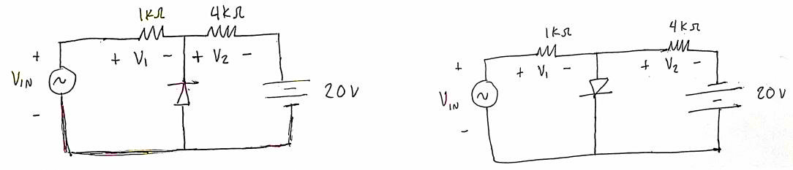

1. Consider the following circuit with an ideal diode and 𝑉𝐼𝑁 = 50𝑆𝑖𝑛(𝜔𝑡). Draw the voltages V1 and V2 with respect to Vin.

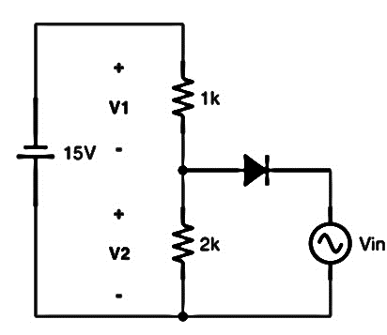

1. Consider the following circuit with an ideal diode and 𝑉𝑖𝑛 = 20 𝑆𝑖𝑛 𝜔𝑡 . Draw the voltages V1 and V2 with respect to Vin.

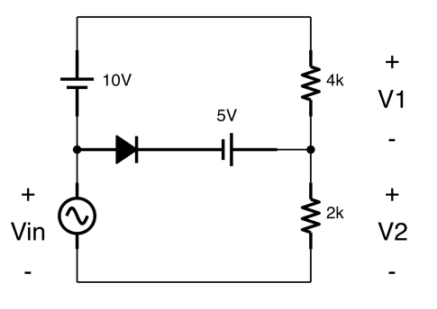

1. Consider the following circuit with an ideal diode and 𝑉𝐼𝑁 = 20𝑆𝑖𝑛(𝜔𝑡). Draw the voltages V1, V2, V3 and Vd with respect to VIN.

